**Assignment 2 - Simulation and Modeling**

**21k-3881**

**BSE-6A**

**CPU Specifications:**

1. **Core-i5 6th Generation**
2. **8GB RAM**

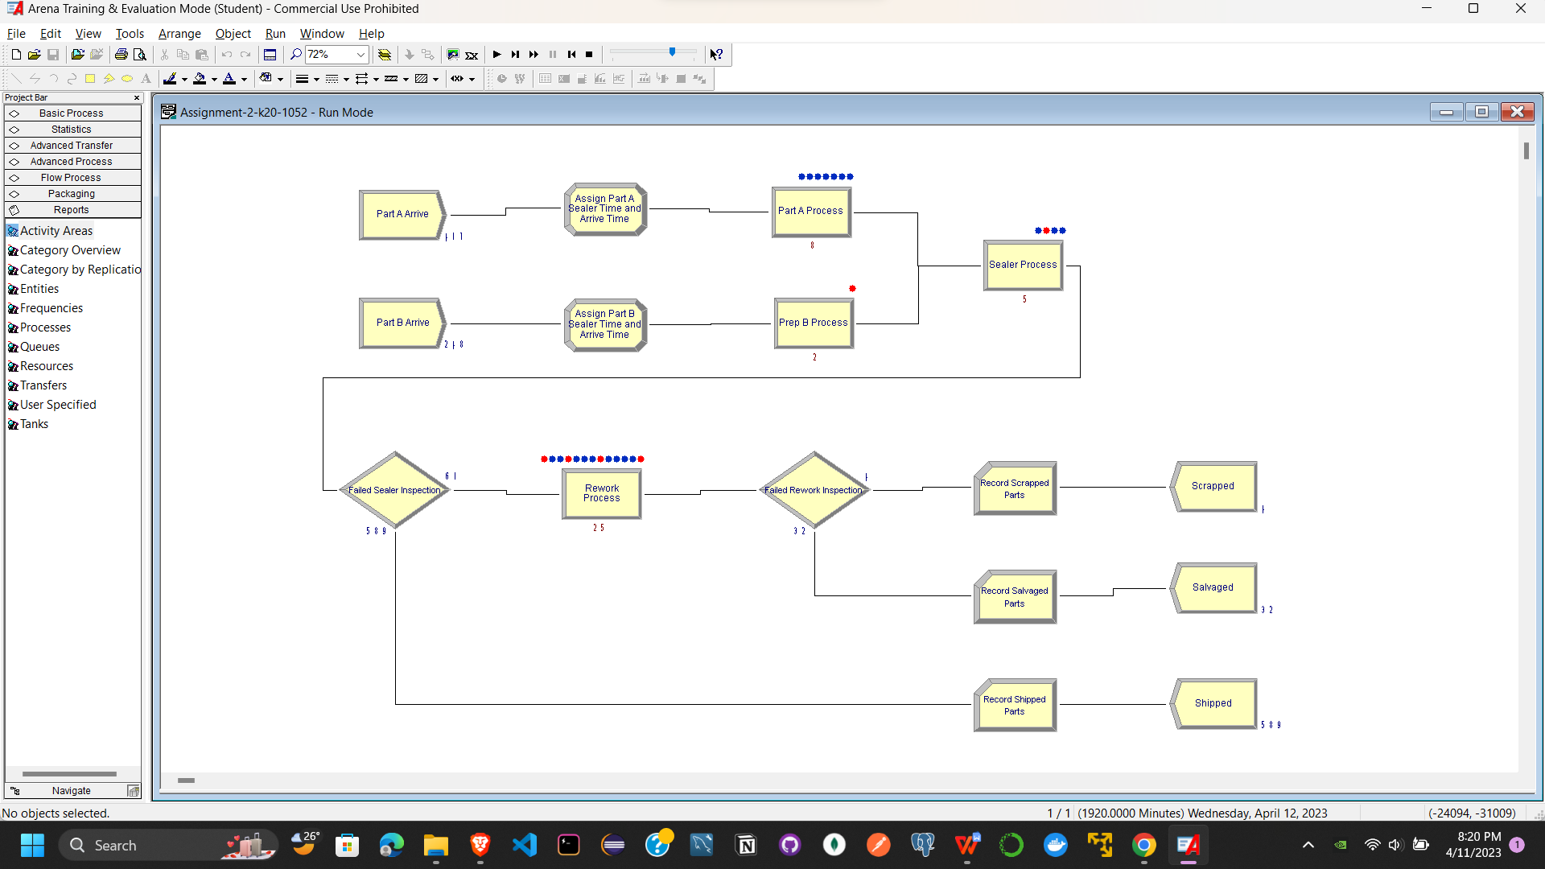

**Part A Arrive**

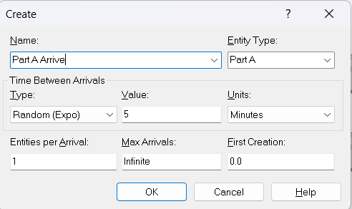

**Part B Arrive**

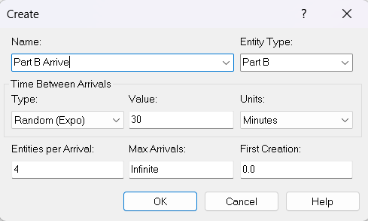

**Assign Part A Sealer Time and Arrive Time**

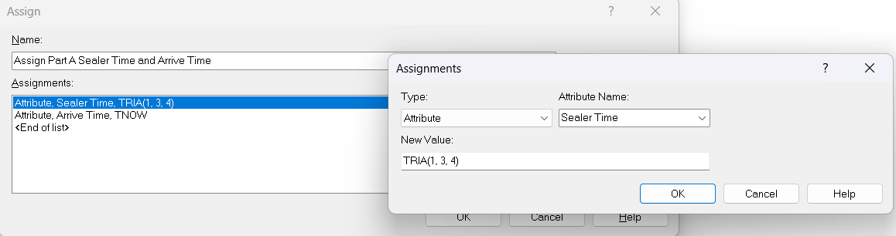

**Assign Part B Sealer Time and Arrive Time**

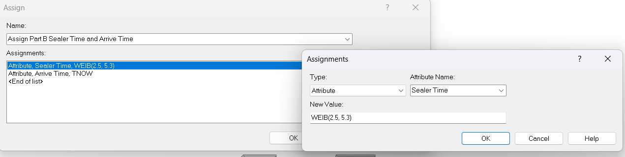

**Part A Process**

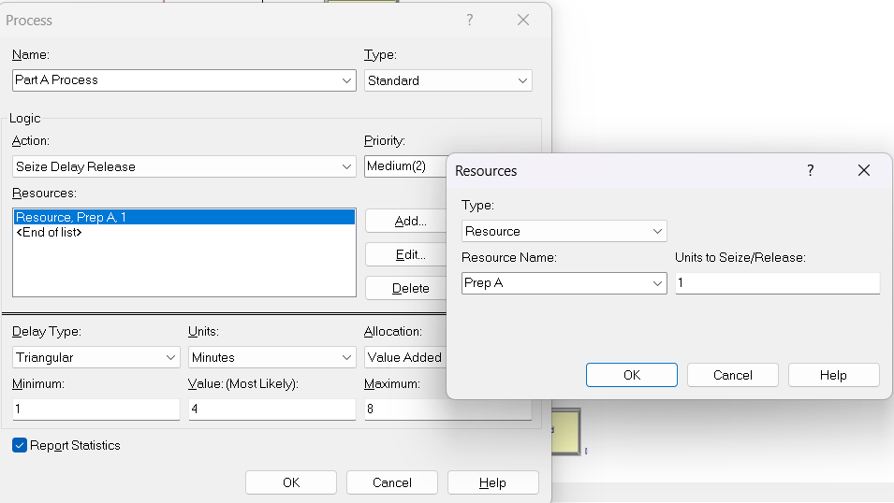

**Part B Process**

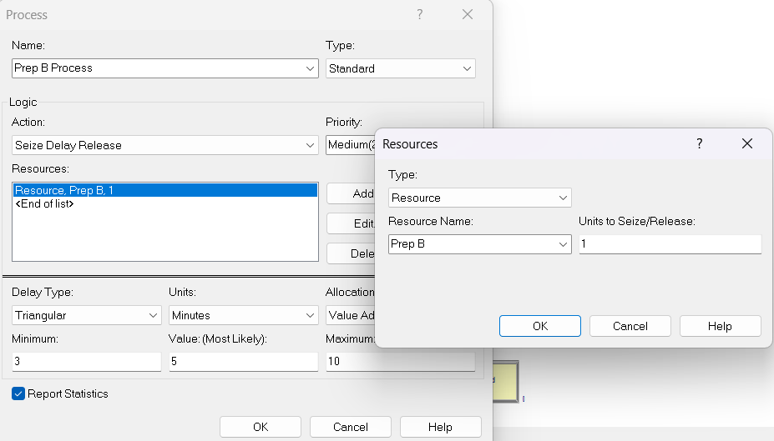

**Sealer Time**

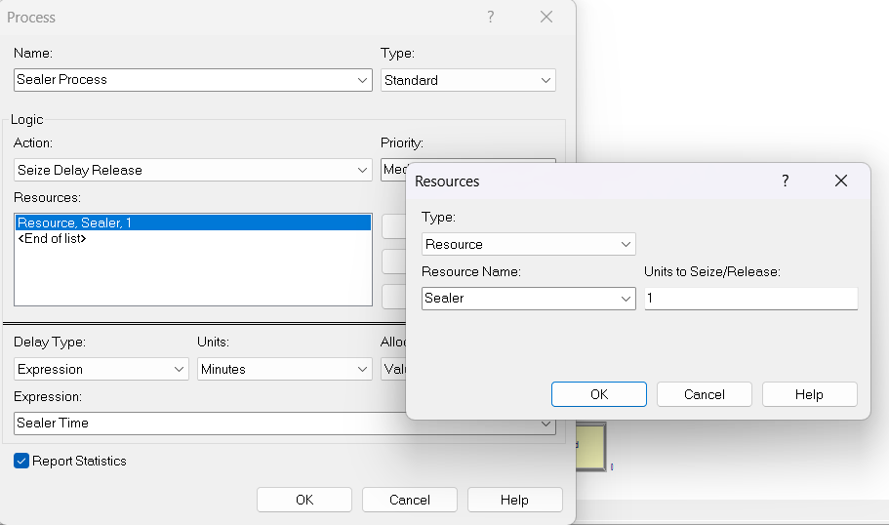

**Failed Sealer Inspection**

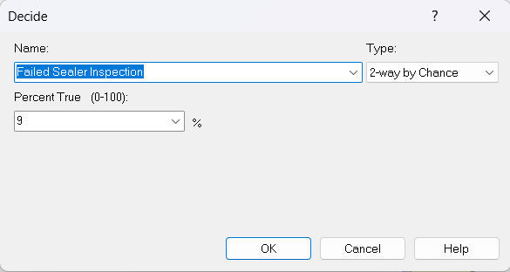

**Rework Process**

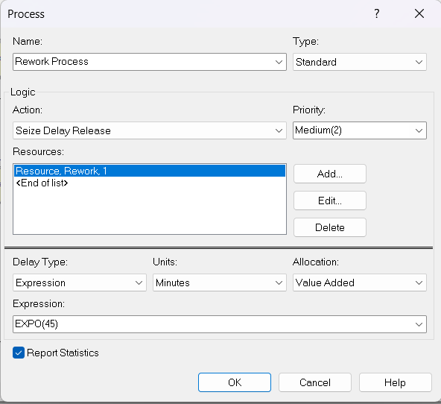

**Failed Rework Inspection**

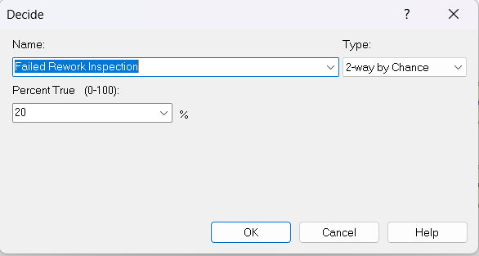

**Record Scrapped Parts**

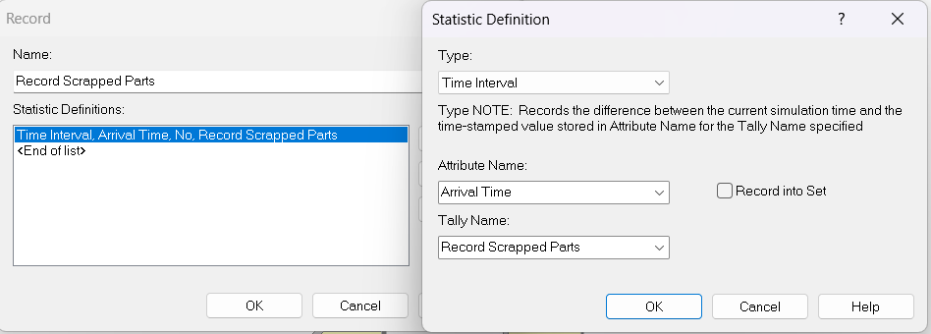

**Record Salvaged Parts**

